* **Explain what is default and required arguments with an example of each.**

1. **Default Arguments**

**-**In this type of arguments function takes default value if no argument is passed during function call.

**-**The default value is set by using ‘=’ operator.

**-**E. g

def value(num=5):

for i in range(num):

print(i,end=',')

print('Values with Arguments ')

value(3)

print('\nValues with Default Arguments')

value()

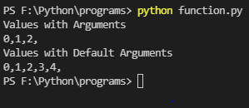

1. **Required Arguments**

**-**In this type of arguments, there are compulsory to passed the values to function.

**-**If anyone of the value is missing then it will throw a type error.

**-**E**.** g

def sub(n1,n2):

print('Subtraction of',n1,'&',n2,':-',n1-n2)

sub(50,20)

print('\nIf one parameter is not given\n')

sub(12)

